# Conflict Scenario

## **Review**

### Interpersonal Conflict Management Styles

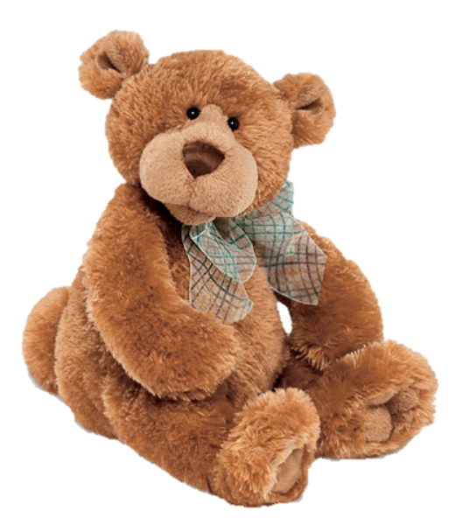

[CC 2.0 BY Matthew](https://www.flickr.com/photos/falcon1961/3304306800/)

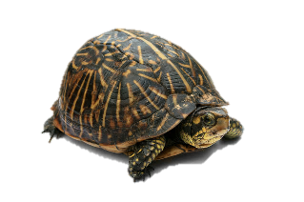

[CC SA 3.0 Unported BY Jonathan Zander](https://en.wikipedia.org/wiki/File:Florida_Box_Turtle_Digon3.jpg)



[CC 3.0 BY Superawesomevectors](https://superawesomevectors.deviantart.com/art/Shark-Cartoon-Free-Vector-Illustration-643399222)



[CC0](https://pixabay.com/en/urban-lost-hiding-afraid-1002149/)

Low to High Concern for Other

Concern for Self

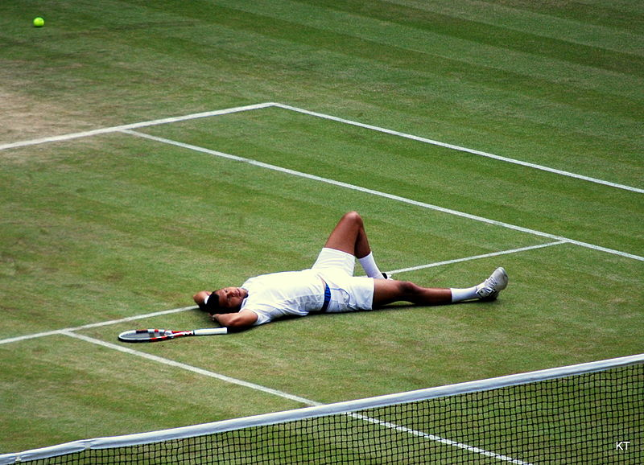

CC SA 2.0 Generic BY [Carine06 from UK](https://commons.wikimedia.org/wiki/File:Flickr_-_Carine06_-_%22I_give_up.%22.jpg)



CC 2.0 BY [Zabara Alexander](https://www.flickr.com/photos/zabara_tango/6955720271)

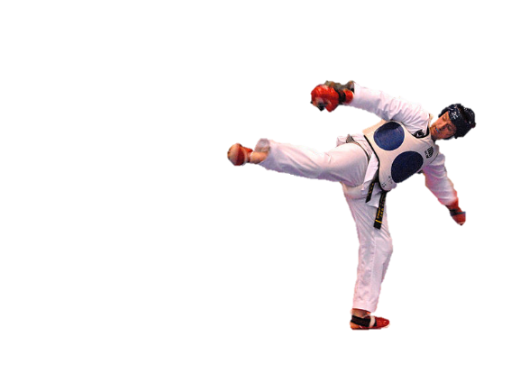

[CC0](https://commons.wikimedia.org/wiki/File:US_Army_53525_Soldiers_compete_in_Tae_Kwon_Do_tournament_for_Warrior_Country_level.jpg)

### **Interpersonal Conflict Resolution**

The following diagram shows a process that can be followed when trying to resolve interpersonal conflict.

### Listening

A considerable proportion of our communication involves listening, yet little attention is devoted to improving listening. HURIER is an acronym for tips that can be used to improve listening.

### “I” Phrases for Conflict Resolution

The “I” phrase is used during conflict resolutions to avoid attacking others. Open the conversation with a statement in first person, passive voice: “I feel … when … because … I would like …”

Adapted from (Dwyer 2012, p. 40)

## **Student Name and ID:**Prabnoor Singh (12192026)

## **Student Name andID:**Satya tejeswar Adapa(12177830)

## **Scenario**

Find a partner.Read the scenario below. Choose one partner to be Joe Bloggs, and the other to be Jane Doe. Together, answer the following to help prepare you for the role play.

## **Scenario:Joe did not complete a task by the deadline**

Joe and Jane are working on a report that is due today. Joe was assigned the task of writing the executive summary. Unfortunately, Joe has not completed the task.

What is the most appropriate conflict management strategy for Jane to use in this situation? (Choose one)

☐Compete/Force

☐Compromise

☐Avoid/Withdraw

☐Collaborate/Confront

☐Accommodate/Smooth

Why did you choose the aboveconflict management strategy?

### We had choose Collaborate/Confront because we want to avoid conflict, if we conflict there will be more problems.

### **Listen and Understand**

How could Janestart the conversation?

Where is your assignment today is the last day to submit it.

Describe the purpose of the discussion. Describe the conflict. What questions could Jane ask to determine Joe’s perspective of the situation?

The purpose is that Jane wants to know why she hadn't completed the assignment,

The conflict was about the reasons behind it. Questions that Jane ask that she haven't

know about the deadline date, but Joe told that she knows the deadline date but its

problem was that she went on a family trip so that's she is not able to do it.

Write sentences thatfeatures the “I” phrase, such as in the example below:

“I feel *[your feeling]* when *[their behaviour]* because *[effects on you]*. I would like *[alternative behaviour]*”.

I feel that you are lying as when you said you had gone on a family trip your behaviour was like you are frustrated because you haven't share any memories or moments you had spent there as well as when you gone a trip you always share me that what you had done there, I would like to ask you because you are my friend is there was any alternative way we will find out it

Invent a reason why Joe did not complete the executive summary by the deadline.

Joe is suntering through lonelmess as she got some personal reasons.

How could Janeparaphrase Joe’s reason for missing the deadline to ensure that she understands Joe’s perspective?

Jane said that as being your friend you can share your problem me we will find out a

reasons as being quiet and sad it will not help you and make you suffer more.

### **Empathise**

Now that JaneunderstandsJoe’sperspective, how could Janeempathise with Joe? Write a response that shows that Jane identifies with Joe’s emotions.

When Jane said this to Joe she got tears in her eyes then Jane understood the problem

after Joe got emotional.

### **Apologise**

Include an apology if it is appropriate.

Then Joc apologies to Jane that its my mistake and I got feared that what will happen, if I tell anyone that I haven't completed my assignment.

### **Offer Solution**

What question could Janeask to help build Joe’s involvement with potential solutions?

Jane said to Joe that don't be afraid I will help you out to complete the assignments.

Come up with a way for Jane and Joeto settle on a solution.

June had a solution that lets we go to the teacher and tell them our reason and she will

understand it and hope we got extension.

### **Resolution**

How could Janeresolve the conflict? Jane needs to ensure that Joe agrees. Write a response that outlines appreciation for the solution.

As they both are good friends Joe feel safe with Jane und Joe got agree with her as there is no other solution, Jane appreciation was she always get ready to help.

### **Reconciliation**

How could Joe reconcilethe relationship and let Jane know that she is important to him?

After she is ready to accept Jane's solution and tell her about its her problems after that she automatically realises that she is important to her.

How can Jane let Joeknow she is listening while Joe is talking?

When Jane is telling something she just keep quiet and listen to her properly as well

they both trust each other.

What could Jane do if Joe started to withdraw from the conflict at any stage?

Jane will ask her to listen to her like well will not get apart at any stage as we are best friends.